**Mary Couhault**

**WebDev Milestone 2 Usability Feedback**

**Goals of the website**

The Goal of the website is to attract new customers to their store or to order online. Online marketing is essential to the modern business work regardless of which industry you are in. This website helps Petite Treats to target many age groups and reach many people to promote to.

**User testing detail**

·  **Name:** Rhizo

· **Age:** 32

·  **Employment:** Game Developer

· **Special interests:** Drawing

**Pre-Test**

1. **Where do you normally look when first opening a site?**

I normally look at the middle images and logo first. I find that my eyes tend to look for those attributes as soon as I open up a website.

1. **What keeps you on a website for longer?**

Interesting layouts and designs keep me interested in websites for a longer period of time. Boring websites make me quickly close the tab.

1. **Have you ever ordered food online before?**

Yes I have, I order food online daily.

**Test Tasks and schedule**

1. Visit Home Page
2. Look at Images on Home Page
3. Visit Menu Page
4. Click on Different products to learn more about them
5. Visit Specials page and look at images
6. Go back to the Home Page, and click subscribe button
7. Enter Details to subscription form

**Post-Test**

**Was the site easy to navigate through the webpage?**

The website was easy to scroll through and to find the products that the bakery made.

**Were there any issues you found on the website?**

There was one image that gave an error and there were also some minor spelling errors. Other than that there was not an issue I could note.

**Seeing this website would you order a product from them?**

Yes, I really enjoyed the layout and would happily order from them.

**Learnability: How easy is it for users to accomplish basic tasks the first time they encounter the design?**

It was very easy to accomplish tasks on the website. I did not have any issues.

**Efficiency: Once users have learned the design, how quickly can they perform tasks?**

It was very easy for me to perform tasks on the site even without learning the design, as I heavily use my computer and browse websites daily.

**Learnability: How easy is it for users to accomplish basic tasks the first time they encounter the design?**

It was very easy for me to accomplish tasks on the website.

**Efficiency: Once users have learned the design, how quickly can they perform tasks?**

Very Quickly, the design is simple and easy to follow.

**Memorability: When users return to the design after a period of not using it, how easily can they reestablish proficiency?**

Very easy, the simplistic design helps for easy navigation

**Errors: How many errors do users make, how severe are these errors, and how easily can they recover from the errors?**

None that I was aware of, everything was simple to do. The form was an easy one that was not a hassle. I liked that.

**Satisfaction: How pleasant is it to use the design?**

10/10, I like simple websites.

My website tester noted that they loved my design however there were some minor issues such as the Eggtart image not loading and some minor spelling issues in the about section. They also noted that they were not sure what was meant by fun value as when they browse websites they are not looking for fun but more so usability. I fixed these errors that they mentioned soon after.

**Usability Scale:**

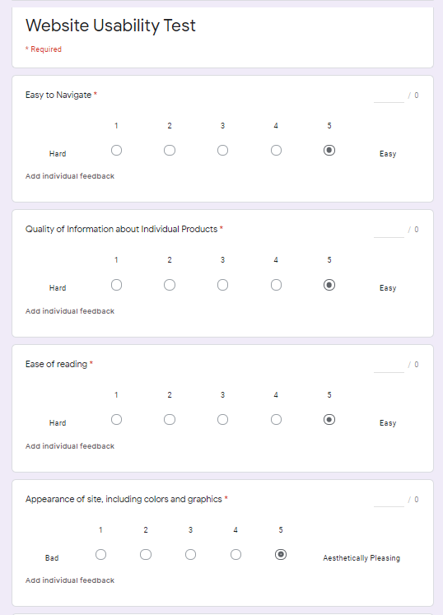

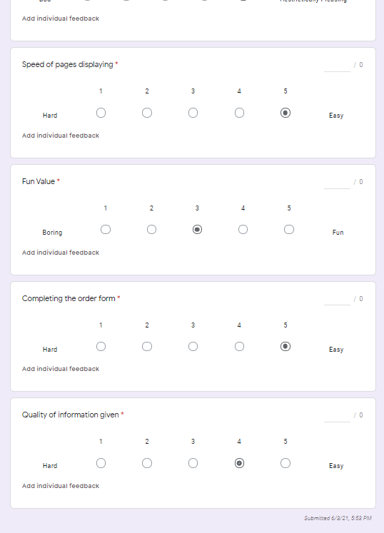

**Improvements that could be made given more time:**

If given a longer time frame, I would have liked to work on further developing the aesthetics of my website and possibly adding a live map feature to show where the bistro is for customers to easily find directions. As well as adding more pictures to the website to make it feel less empty. I would have liked to also implement a moving menu that had motion graphics to grab more people's attention and keep them interest in the design of the website and as well as to

better showcase the food offered.